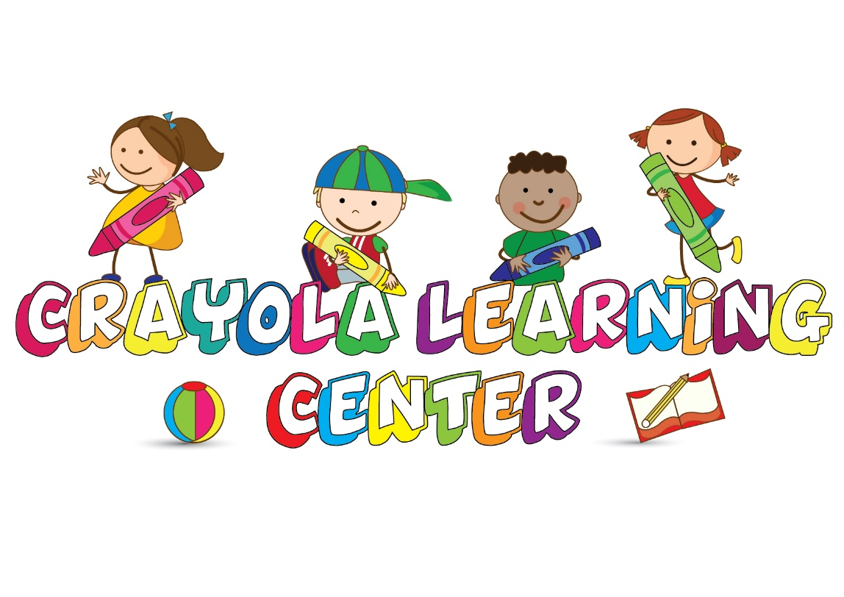 |  | - December 2017  - Christmas Day – Closed  - December 26- Closed  - New Year’s Eve- Parent Night Out  - New Year’s Day- Closed

Ms. Ebony Class
This month Ms. Ebony will be teaching Christmas All month long. The children will learn all about Christmas and all that it has to offer. Ms. Ebony will implement daily activities in her lessons through Art, Sensory/Science, Fine/Gross motor Skills, Literacy, Math, and of course Music/Movement.
Activities
December 4th-Candy Cane Craft
December 5th-Ugly Sweater Craft
December 6th- Decorate Ornaments
December 7th-Reindeer Craft
December 8th- Jammies & Jingles
December 11th- Christmas Tree Craft
December 12th-Decorate Christmas Stockings
December 13th-Hot Cocoa Craft
December 14th-Mr..Ginger Bread Craft
December 15th-The Grinch & PJ’S
December 18th-Santa Claus Craft
December 19th-Build a Snowman
December 20th-Mail Letters to Santa
December 21st-Bake Cookies for Santa
December 22nd-Santa Claus is coming to town

Ms. Genevive Class
Ms. G will implement her Christmas lessons through reading, music and movement, also infant friendly holiday art projects. Our infants will also be participating in tummy time/floor time as well to strengthens those little muscles.
Lesson Plan
Letters of the Month
A-F
Numbers of the Month
10-11
Shapes of the Month
Square & Heart
Colors of the Month
Red & Green

From the Office
The Office staff here at Crayola Learning Center appreciates all our parents and staff for part taking in our holiday activities. The year is all most over but we are just getting started. We are looking for an even better 2018 with the help of our team. Happy Holidays!!!

Christmas All Month Long

Popcorn Fundraiser
Our Double Good Popcorn fundraiser starts December 1 through December 15. Order forms will be given out on Friday, December 1. We hope all Parents Participate and we will have a small token of appreciation for the parent who has the most sells.
New Year Eve Parent Night Out
Our Parent Night is being held on New Year’s Eve from 6:30pm-9:00 am New Year Day. $20 per child, none enrolled children welcomed but must be toilet trained.

